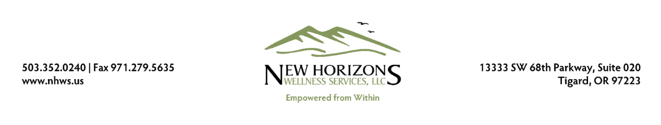
You have the right to receive a “Good Faith Estimate” explaining how much your medical care will cost

Under the law, health care providers need to give patients who don’t have insurance or who are not using insurance an estimate of the bill for medical items and services.

- You have the right to receive a Good Faith Estimate for the total expected cost of any non-emergency items or services. This includes related costs like medical tests, prescription drugs, equipment, and hospital fees.

- Make sure your health care provider gives you a Good Faith Estimate in writing at least 1 business day before your medical service or item. You can also ask your health care provider, and any other provider you choose, for a Good Faith Estimate before you schedule an item or service.

- If you receive a bill that is at least $400 more than your Good Faith Estimate, you can dispute the bill.

- Make sure to save a copy or picture of your Good Faith Estimate.

For questions or more information about your right to a Good Faith Estimate, visit www.cms.gov/nosurprises or call (503) 352-0240.

